UNIVERZITET U BIHAĆU

TEHNIČKI FAKULTET

ODSJEK ELEKTROTEHNIKA

SMJER INFORMATIKA

Seminarski rad

**Operativni sistemi**

Mini informacioni sistem

-Nogomet-

Profesor: Student:

Dr. Mehmed Arnautović Adis Salihodžić, 798

**SADRŽAJ**

1. NOGOMET............................................................................................................................ 3

1.1 SCENARIO.............................................................................................................. 3

2. RELACIONI MODEL (KOD)............................................................................................... 3

3. KONCEPTUALNI MODEL.................................................................................................. 3

4. SQL KOD BAZE (baza_nogomet)........................................................................................ 3

5. WEB APLIKACIJA............................................................................................................... 8

5.1 POČETNA STRANICA (index.php)....................................................................... 8

5.2 UNOS KLUBOVA (klub.php)................................................................................. 8

5.3 UNOS IGRAČA (igraci.php)................................................................................. 10

5.4 ISPIS TABELA (lista.php).................................................................................... 13

5.5 ODJAVA (odjava.php).......................................................................................... 17

5.6 LOGIN FORMA (pocetna.php)............................................................................. 17

**1. Nogomet**

**1.1 Scenario:**

Vodi se evidencija o nogometnim klobovima i igračima koji igraju za te klubove. Omogućen je unos novih klubova, igrača i njihovih osobina, registracija i login, te ispis klobova, igrača i osobina.

Za svaki klub poznato je id_klub i naziv kluba. Za svakog igrača poznato je id_igraca, naziv , opis i klub. Programu se moze pristupiti kao admin i ako korisnik. Admin ima veća ovaštenja te može mijenjati stanje kako kluba tako i igrača, dok je korisniku omogućeno samo da vidi trenutno stanje klubova i igrača te njihovih opisa.

**2. Relacioni model (kod):**

Klub<PK 'idklub', 'naziv' >

Igraci<PK 'idigraci', 'naziv', 'opis', 'klub' >

***Izvedena tabela:***

Korisnik<PK 'idkorisnik', 'username', 'pasword', 'admin' >

**3. Konceptualni model:**

|  |
| --- |
| korisnik |

|  |
| --- |
| klub |

|  |
| --- |
| igraci |

**4. SQL kod baze (baza_nogomet):**

-- phpMyAdmin SQL Dump

-- version 4.1.14

-- http://www.phpmyadmin.net

--

-- Host: 127.0.0.1

-- Generation Time: Dec 02, 2015 at 06:54 PM

-- Server version: 5.6.17

-- PHP Version: 5.5.12

SET SQL_MODE = "NO_AUTO_VALUE_ON_ZERO";

SET time_zone = "+00:00";

/*!40101 SET @OLD_CHARACTER_SET_CLIENT=@@CHARACTER_SET_CLIENT */;

/*!40101 SET @OLD_CHARACTER_SET_RESULTS=@@CHARACTER_SET_RESULTS */;

/*!40101 SET @OLD_COLLATION_CONNECTION=@@COLLATION_CONNECTION */;

/*!40101 SET NAMES utf8 */;

--

-- Database: `baza_nogomet`

--

-- --------------------------------------------------------

--

-- Table structure for table `igraci`

--

CREATE TABLE IF NOT EXISTS `igraci` (

`idigraci` int(11) NOT NULL AUTO_INCREMENT,

`naziv` varchar(45) COLLATE utf8_unicode_ci NOT NULL,

`opis` varchar(45) COLLATE utf8_unicode_ci NOT NULL,

`klub` int(11) NOT NULL,

PRIMARY KEY (`idigraci`)

) ENGINE=InnoDB DEFAULT CHARSET=utf8 COLLATE=utf8_unicode_ci AUTO_INCREMENT=8 ;

--

-- Dumping data for table `igraci`

--

INSERT INTO `igraci` (`idigraci`, `naziv`, `opis`, `klub`) VALUES

(1, 'Lionel Messi', 'malen', 1),

(2, 'Cristiano Ronaldo ', 'fizički spreman', 2),

(3, 'Philip Lahm', 'veoma snalažljiv', 3),

(4, 'Theo Walcott', 'brz', 4),

(5, 'Marco Reus', 'timski igrač', 5),

(6, 'Senad Lulić', 'borben', 6),

(7, 'Fadil Čizmić', 'miljenik navijača', 7);

-- --------------------------------------------------------

--

-- Table structure for table `klub`

--

CREATE TABLE IF NOT EXISTS `klub` (

`idklub` int(11) NOT NULL AUTO_INCREMENT,

`naziv` varchar(45) COLLATE utf8_unicode_ci NOT NULL,

PRIMARY KEY (`idklub`)

) ENGINE=InnoDB DEFAULT CHARSET=utf8 COLLATE=utf8_unicode_ci AUTO_INCREMENT=8 ;

--

-- Dumping data for table `klub`

--

INSERT INTO `klub` (`idklub`, `naziv`) VALUES

(1, 'Barcelona'),

(2, 'Real Madrid'),

(3, 'Bayern Minchen'),

(4, 'Arsenal'),

(5, 'Borussia Dortmund'),

(6, 'Lazio'),

(7, 'NK Jedinstvo Bihać');

-- -------------------------------------------------------

-- Table structure for table `korisnik`

--

CREATE TABLE IF NOT EXISTS `korisnik` (

`idkorisnik` int(10) unsigned NOT NULL AUTO_INCREMENT,

`username` varchar(45) NOT NULL,

`password` varchar(45) NOT NULL,

`admin` tinyint(1) NOT NULL,

PRIMARY KEY (`idkorisnik`)

) ENGINE=InnoDB DEFAULT CHARSET=utf8 AUTO_INCREMENT=4 ;

--

-- Prikaz podataka tabele `korisnik`

--

INSERT INTO `korisnik` (`idkorisnik`, `username`, `password`, `admin`) VALUES

(1, 'admin', 'admin', 1),

(2, 'korisnik', 'korisnik', 0);

/*!40101 SET CHARACTER_SET_CLIENT=@OLD_CHARACTER_SET_CLIENT */;

/*!40101 SET CHARACTER_SET_RESULTS=@OLD_CHARACTER_SET_RESULTS */;

/*!40101 SET COLLATION_CONNECTION=@OLD_COLLATION_CONNECTION */;

/*!40101 SET CHARACTER_SET_CLIENT=@OLD_CHARACTER_SET_CLIENT */;

/*!40101 SET CHARACTER_SET_RESULTS=@OLD_CHARACTER_SET_RESULTS */;

/*!40101 SET COLLATION_CONNECTION=@OLD_COLLATION_CONNECTION */;

**5. Web aplikacija**

**5.1 Početna stranica (index.php)**

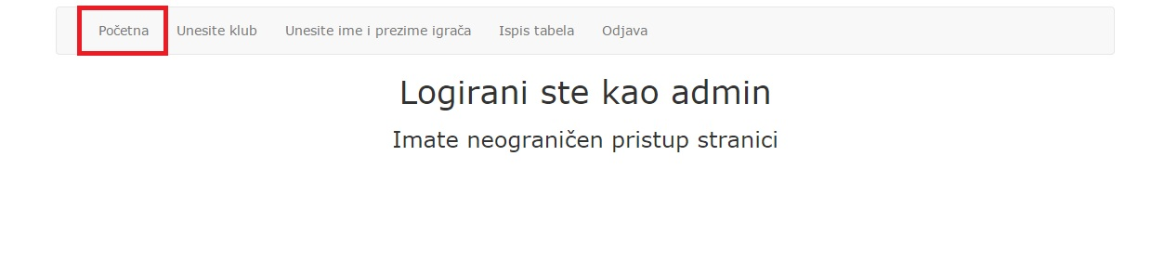

<?php

include "db_konekcija.php";

include "header.php";

include "footer.php;"

?>

**5.2 Unos klubova (klub.php)**

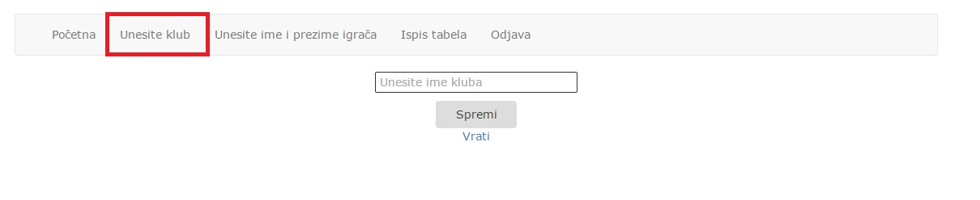

<?php

error_reporting(0);

session_start();

if(!$_SESSION['id'])

header('Location: index.php');

include "db_konekcija.php";

if(isset($_POST["spremi"])){

$naziv=$_POST["naziv"];

$sql2="insert into klub values (0,'$naziv')";

$query2=mysql_query($sql2);

if($query2)

echo "Uspjesan unos";

else

echo "Unos nije uspjesan";

}

?>

<html>

<head>

<meta charset="UTF-8">

<title>Nogomet</title>

<link rel="stylesheet" href="css/bootstrap.min.css">

<link rel="stylesheet" href="css/style.css">

</head>

<body>

<div class="container">

<?php

include "navigacija.php";

?>

<form method="POST">

<p><input type="text" name="naziv" placeholder="Unesite ime kluba "/><br></p>

<input class="btn" type="submit" name="btn" value="Spremi"/>

<p><a href="index.php">Vrati</a></p>

</form>

</div>

</body>

</html>

**5.3 Unos igrača (igraci.php)**

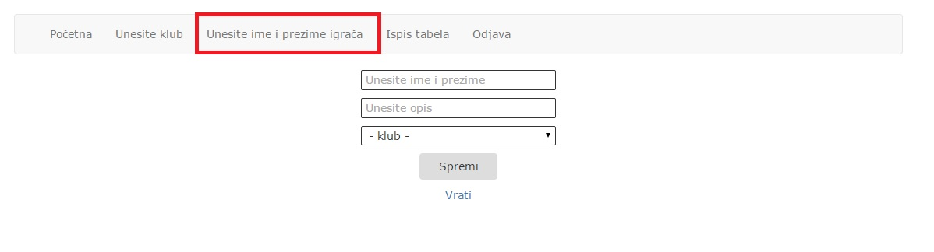

<?php

error_reporting(0);

session_start();

if(!$_SESSION['id'])

header('Location: index.php');

include "db_konekcija.php";

if(isset($_POST["btn"])){

$naziv=$_POST["naziv"];

$opis=$_POST["opis"];

$klubid=$_POST["klubid"];

$sql2="insert into igraci values (0,'$naziv','$opis','$klubid')";

$query2=mysql_query($sql2);

if($query2)

echo "Uspjesan unos";

else

echo "Unos nije uspjesan";

}

?>

<html>

<head>

<meta charset="UTF-8">

<title>Nogomet</title>

<link rel="stylesheet" href="css/bootstrap.min.css">

<link rel="stylesheet" href="css/style.css">

</head>

<body>

<div class="container">

<?php

include "navigacija.php";

?>

<form method="POST">

<p><input type="text" name="naziv" placeholder="Unesite ime i prezime"/><br></p>

<p><input type="text" name="opis" placeholder="Unesite opis"/><br></p>

<p>

<select name="klub">

<option value="none">- klub -</option>

<?php

$sql2="select * from klub";

$query2=mysql_query($sql2);

while($row=mysql_fetch_array($query2)){

?>

<option value="<?php echo $row["naziv"] ?>"><?php echo $row["naziv"] ?></option>

<?php

}

?>

</select>

<p>

<input class="btn" type="submit" name="btn" value="Spremi"/>

<p><a href="index.php">Vrati</a></p>

</form>

</div>

</body>

</html>

**5.4 Ispis tabela(lista.php)**

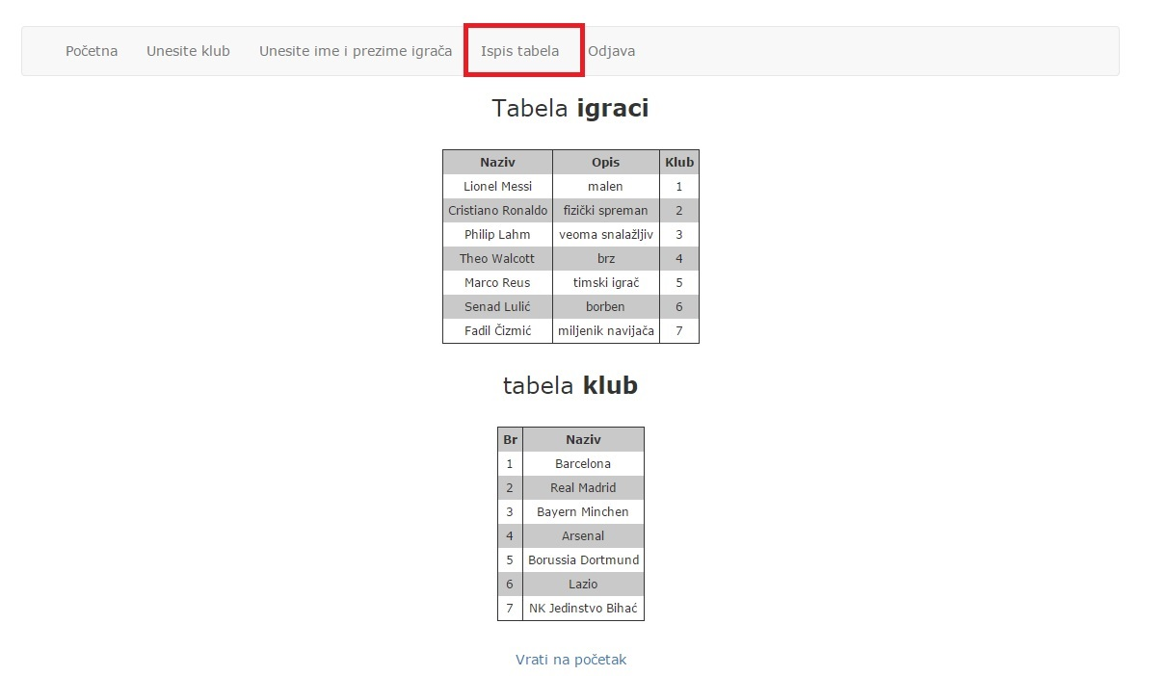

<?php

error_reporting(0);

session_start();

if(!$_SESSION['id'])

header('Location: index.php');

include "db_konekcija.php"

?>

<html>

<head>

<meta charset="UTF-8">

<title>Nogomet</title>

<link rel="stylesheet" href="css/bootstrap.min.css">

<link rel="stylesheet" href="css/style.css">

</head>

<body>

<div class="container">

<?php

include "navigacija.php";

?>

<h3>Tabela <strong>igraci</strong></h3>

<table>

<tr>

<th>Naziv</th>

<th>Opis</th>

<th>Klub</th>

</tr>

<?php

$sql = "SELECT * FROM igraci";

$query = mysql_query($sql);

while($row = mysql_fetch_array($query)):

?>

<tr>

<td>

<?php echo $row["naziv"]; ?>

</td>

<td>

<?php echo $row["opis"]; ?>

</td>

<td>

<?php echo $row["klub"]; ?>

</td>

</tr>

<?php

endwhile;

?>

</table>

<h3>tabela <strong>klub</strong></h3>

<table>

<tr>

<th>Br</th>

<th>Naziv</th>

</tr>

<?php

$sql = "SELECT * FROM klub";

$query = mysql_query($sql);

while($row = mysql_fetch_array($query)):

?>

<tr>

<td>

<?php echo $row["idklub"]; ?>

</td>

<td>

<?php echo $row["naziv"]; ?>

</td>

</tr>

<?php

endwhile;

?>

</table>

<p><a href="index.php">Vrati na početak</a></p>

</div>

</body>

</html>

**5.5 Odjava (odjava.php)**

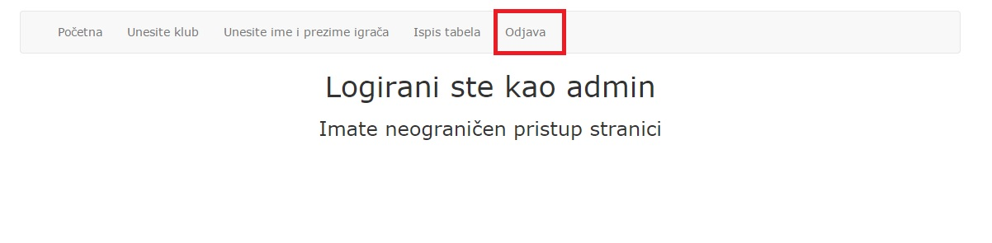

<?php

error_reporting(0);

session_start();

session_destroy();

header('Location: index.php');

?>

**5.6 Login forma (pocetna.php)**

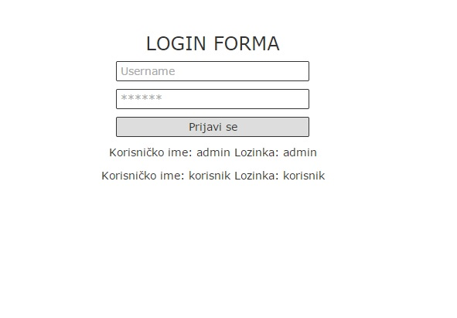

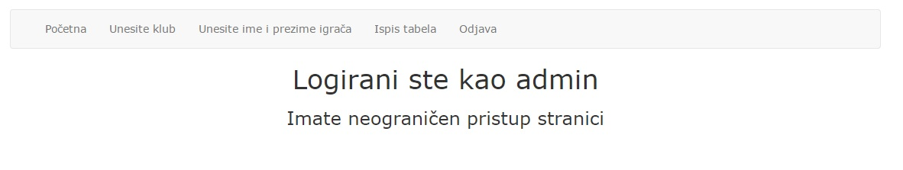

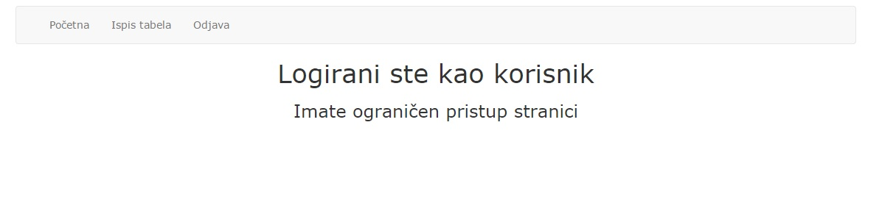

<?php

error_reporting(0);

/*

* To change this template, choose Tools | Templates

* and open the template in the editor.

*/

session_start();

if(!$_SESSION['id'])

header('Location: index.php');

?>

<html>

<head>

<meta charset="utf-8" >

<title>Nogomet - LOGIN</title>

<link rel="stylesheet" href="css/bootstrap.min.css">

<link rel="stylesheet" href="css/style.css">

</head>

<body>

<div class="container">

<?php

include "navigacija.php";

?>

<?php if($_SESSION['admin']==1){ ?>

<h1>Logirani ste kao admin </h1>

<h3>Imate neograničen pristup stranici</h3>

<?php } ?>

<?php if($_SESSION['admin']==0){ ?>

<h1>Logirani ste kao korisnik</h1>

<h3>Imate ograničen pristup stranici</h3>

<?php } ?>

</div>

</body>

</html>